Writer: Tiffany Floyd

**Rassam, Abdul Qadir al-** (1882-1952)

Born in Baghdad, Iraq, Abdul Qadir al-Rassam was part of the first generation of modern Iraqi painters. He was among a group of soldier-artists who are credited with introducing easel painting to Iraq at the turn of the century. He began his education around 1904 when the Ottoman Empire was still the main power in the region. He studied military science and art in Istanbul. As part of his education in Istanbul, al-Rassam and his classmates were required to produce paintings or drawings for military use. These images adhered to a strict European academic style. Eager to cultivate their new skill, these officers sought out private art training. Al-Rassam himself studied under a number of prominent painters living in Istanbul who worked in contemporary French styles. Although he is most recognisable as an oil painter, al-Rassam experimented with watercolors representing Istanbul with its crowds and markets. Even at this early stage in his career, he showed expert skills and a conscientious eye. Al-Rassam’s ambitions were interrupted by the outbreak of WWI. Directly following the war, when the group of soldier-artists returned to Iraq, al-Rassam again took up easel painting. Along with his colleagues, he focused on landscapes, military scenes, and archaeological sites.

An important characteristic of this initial generation was their desire to stimulate awareness and appreciation of the arts amongst the Iraqi population. Al-Rassam taught painting lessons out of his studio in Baghdad and encouraged young artists to continue their art training abroad. Many artists who studied under al-Rassam became important members of the Iraqi modern art movement. The painter’s interest in promoting art awareness was further realized when he became an honorary member of the Society of the Friends of Art, a group that sought to cultivate public interest in art making and to enhance their own skill through interaction.

Utilizing the same academic style as his early colleagues, al-Rassam painted with a crisp realism capturing vistas of the Iraqi countryside, especially scenes of the Tigris and its surroundings. Al-Rassan was also a portraitist. One of his well-known portraits is of Mohamed Darouich al Allousi, completed in 1924. The subtleties of the face show the painter’s mastery of modeling and the poignant gaze reflect his skill as a keen observer.

A collection of al-Rassam’s works is held at the Pioneers Museum in Baghdad. He also created a mural for the entrance of a movie theater in Baghdad, The Royal Cinema. This was the first large-scale work of art to be displayed on a public building. Later in his life, the artist travelled to Italy, France, Germany, and England to expand his knowledge of art. Abdul Qadir al-Rassam is considered one of the most prominent and prolific painters in Iraq’s modern art history and his work heavily influenced the generations that followed.

**References and further reading**:

Ali, Wijdan. *Modern Islamic Art: Development and Continuity*. Gainsville: Florida University Press, 1997.

Jabra, Jabra I. (1983) *The Grass Roots of Iraqi Art*. Jersey: Wasit Graphic and Publishing Limited.

*Modern Art Iraq Archive*. <http://artiraq.org/maia/>

Mudaffar, May (1989), “Iraq” in *Contemporary Art from the Islamic World*, edited by Wijdan Ali. Amman: The Royal Society of Fine Arts, Essex, England: Scorpion Publishing.

Saad, Qassim (2008), "Contemporary Iraqi Art: Origins and Development." *Scope: Contemporary Research Topics* (Art & Design), 3, 50-54.

*Modern Art Iraq Archive*. <http://artiraq.org/maia/>

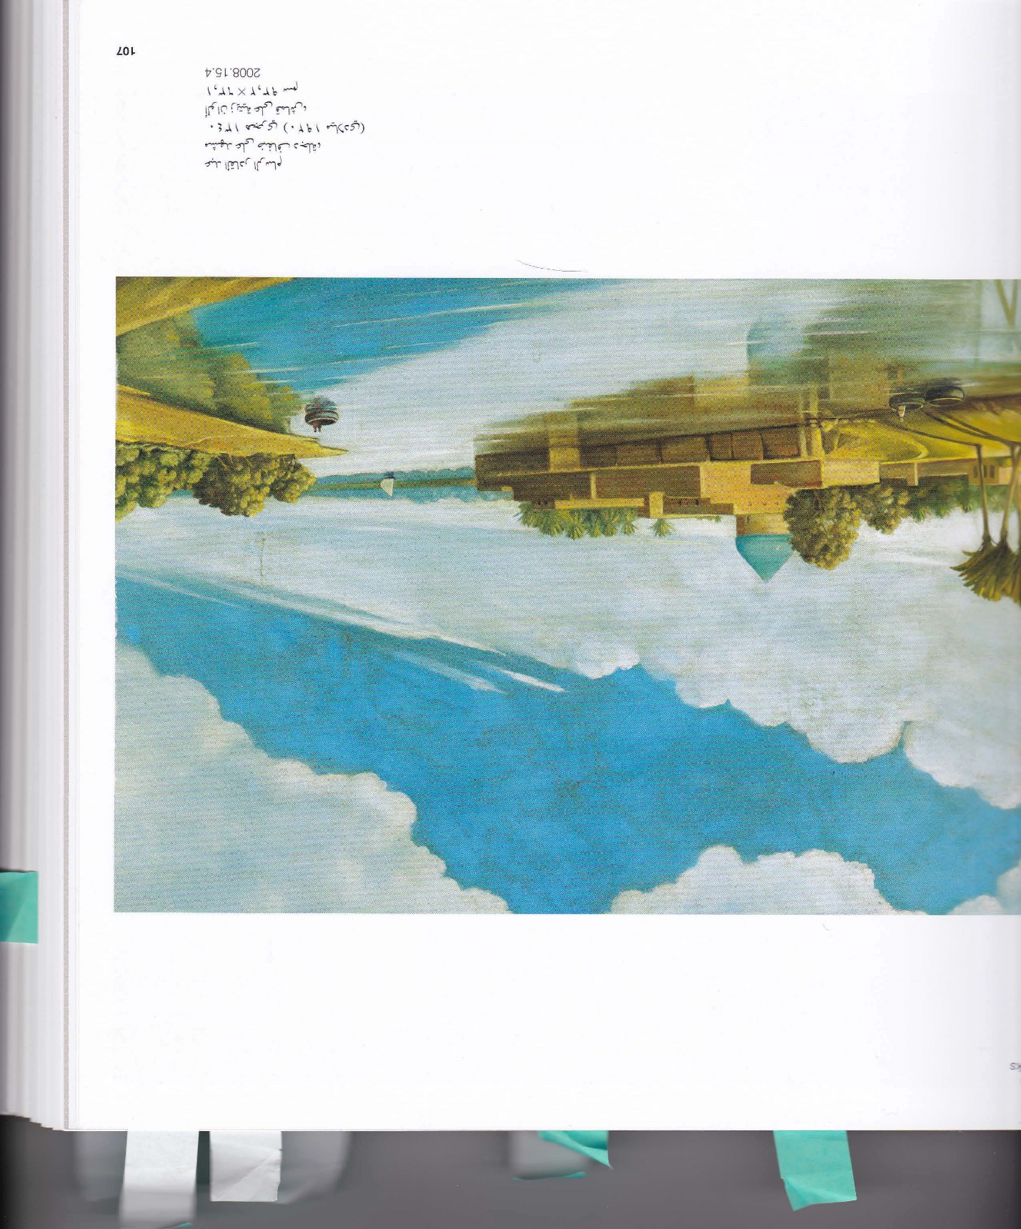

Abdul Qadir al-Rassam

*River Scene on the banks of the Tigris*, 1920

Oil on canvas

63.1 x 93.2 cm

Mathaf: Arab Museum of Modern Art

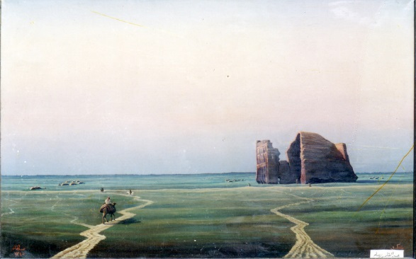

Abdul Qadir al-Rassam

Title Not Known, n.d.

Modern Art Iraq Archive, MAIA (artiraq.org) (Nada Shabout has copyright for this)